Title: Industry Analysis & Economics of the business
Name:
School:
Date:
Introduction
Name of the proposed business
Kinetic Energy Harvesting Fashionable Wearables (official name to come)
One paragraph summary of the business
Kinetic Energy Harvesting Fashionable Wearables is a wearable that creates Kinetic Energy as you move. The goal of the business is to create a product that allows you to collect energy and utilize that energy to charge your phone. Our company will start in Pittsburgh and will grow to the surrounding areas. The business will be involved in the production of a battery that can convert the body’s heat into electricity and that electricity can be used to charge any phone while in the pocket. Massachusetts institute of technology researchers recently found that self-charging battery can salvage low temperature sources of heat their energy. So the business will want to put this in practice and manufacture a pocket size battery that will harvest body heat. The battery will be able to charge it self in temperatures between 20⁰C and 60⁰C.
Financial Feasibility
Issues Addressed in This Part
A. | Total startup cash needed  Since the business is starting from scratch, it will need a significance amount of capital with at least $80,000. This capital will enable the business to secure equipment and machinery for the manufacturing of the product. It will also help the company to cater for labor and occupational space among other business requirements.
B. | Financial performance of similar businesses  Many other businesses that are doing the same business have been able to run will a relatively low amount of capital but they needed more than $90,000 to start up. The businesses are not able to record a good profit margin at the start up but once the business matures, it starts paying off. The profit margin of some of the business which have been in the market for long can stretch up to $10,000,000-$50,000,000 annually.
C. | Overall financial attractiveness of the proposed venture  The financial attractiveness for this venture requires patience. The business has to fight for its market share and that requires time. So it is not an overnight millionaire business but once it gets accepted by the market segments that it works towards satisfying their needs, the business becomes lucrative.
Assessment Tools
Total Start-Up Cash Needed
The startup costs will be used to support; capital investments and operating expenses, hiring of personnel, office or manufacturing space, equipment, training, research and development, marketing, and the initial product rollout. The figure below gives the business of an idea the dollar amount that will be needed to launch the firm. The money can be acquired from financial institutions or investors. E.g. capitalist and Angel investors.

Balance Sheet for the first Financial year.
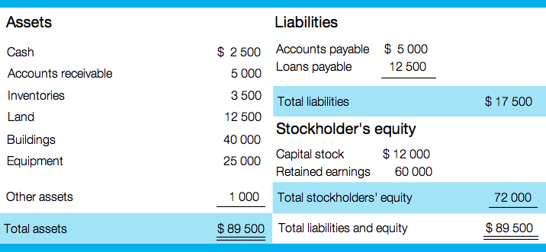
Core strategy of the business.
The business is aimed at utilizing green ways of generating energy in the wake of global warming warnings. The business is inclined to social entrepreneurship where it will manufacture and sell kinetic energy batteries. The products will majorly depend on kinetic, static, and solar energies and it will target the low income earners at the beginning and later on the whole energy market.
Mission
To produce green energy products
Resources needed.
The resources needed include machinery and equipment, land, buildings, and any other assets that will enable the business to run smoothly.
Operations
The operations of the business include; manufacture and selling of the products, distribution of products and services as well as marketing and advertising.
- Financials
The company will earn its revenue from the sales it is going to make form the sales of the batteries. In the future after the business grows, may be it will be able to come up with other ways of revenue such as manufacture of chargers and solar panels.
- Cost Structure
The business will spend in the following activities:
Labor, marketing and advertising, and manufacturing costs among other costs.
The following is an estimation of the cost structure in the business start-up.
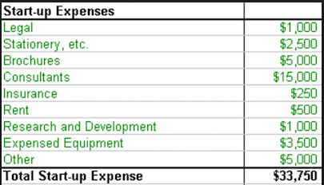

Works Cited
Moore, Carlos W, and Justin G. Longenecker. Managing Small Business: An Entrepreneurial Emphasis. Australia: South-Western/Cengage Learning, 2011. Print.
Nye, Judy. Pricing Your Products and Services Profitably. Washington, D.C.?: U.S. Small Business Administration, Office of Business Development, 2015. Print.

